**RISKS TO EVALUATE BEFORE TRADING**

**PERPETUAL FUTURES CONTRACT**

***Traders are making colossal profits from perpetual futures contracts. But there are three risks to be aware of before trading perpetual futures contract.***

For the past few years, countless exchanges began to offer altcoin futures quoted in Tether ([USDT](https://cointelegraph.com/tether-price-index)) and stablecoin pairs. This development has become convenient for most traders. However, it still presents some serious issues.

Prior to opening any trade at an exchange offering perpetual futures contract, traders should be aware of 3 things. Stronger wicks can run stop-loss. Investors lose the capability to stake their altcoins for profitable yields. And the variable funding rate can remarkably increase the costs of carrying a trade.

**Leverage leads to stronger wicks**

Leverage will result in stronger wicks regardless of the liquidity of the market. Although these moves normally don't lead to forced liquidation, it might run an investors’ stops.

Hence, the possibility of roving wicks are the main reason for traders to avoid holding futures positions for more extended periods.

Futures liquidation engines uses a price index composed of multiple spot (regular) exchanges. Mainly to avoid price manipulation. Therefore, the system will close positions with inadequate margin once an index comes to stops.

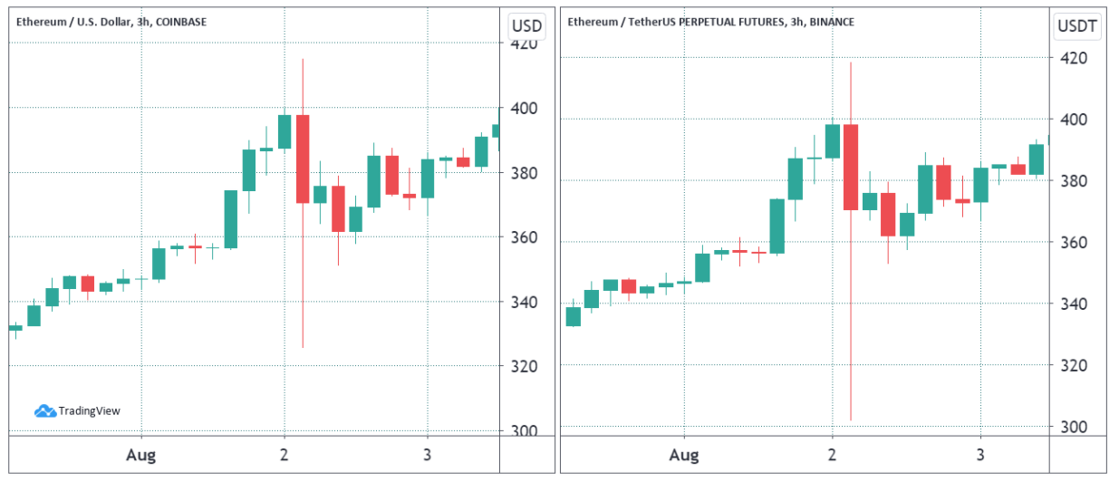

Ether Coinbase and Binance perpetual futures. Source: Tradingview

Noticeably, ETH has a $326 low on Coinbase, while Binance futures faced a $302 low. This change might be small, but certainly triggered traders' stop orders.

A way to avoid such issues would be to simply set one's stop orders trigger to Mark Price (Index) instead of Last Price.

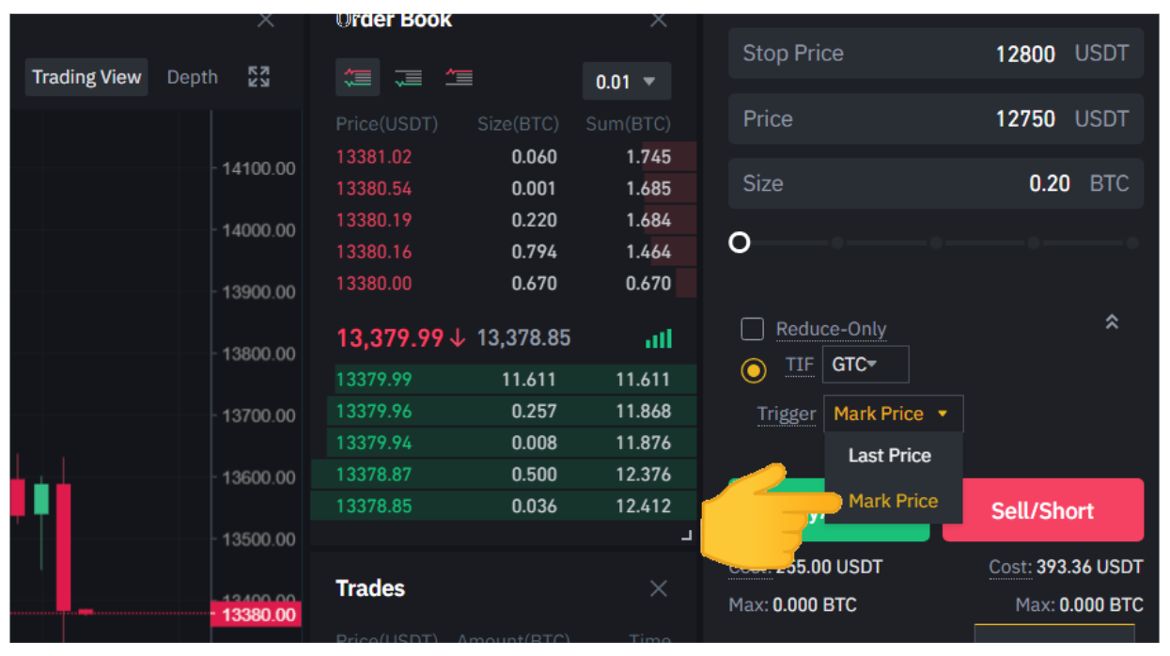

BTC futures contract trigger price selection. Source: Binance

This simple change could avoid liquidation if futures contracts monetarily decouple from its index. Although not every exchange offers this possibility.

**Staking and liquidity mining could provide better yield**

There are innumerable platforms offering staking and lending services. Some altcoins offer 30-day contract annual percentage yields (APY).It can range from 7% to 18% are Polkadot ([DOT](https://coinmarketcap.com/currencies/polkadot-new/)), Tron ([TRX](https://cointelegraph.com/tron-price-index)), Cosmos ([ATOM](https://cointelegraph.com/cosmos-price-index)), and Cardano ([ADA](https://cointelegraph.com/ada-price-index)).

[Decentralized (DeFi) mining pools](https://cointelegraph.com/news/earning-with-defi-yield-farming-rocket-science-or-child-s-play) could be another way of generating income by holding altcoins. Users should beware of this sector’s risks. Especially pools with impairment loss occurring between two different cryptocurrencies.

By opting for perpetual futures contract, it would be unable to partake in staking and yield farming.

**Watch out for fluctuating funding rates**

Perpetual futures contracts, also known as inverse swaps, have an embedded rate. These are usually charged every eight hours. Funding rates make sure that there are no exchange risk variation.

When buyers are the ones exacting more leverage, the funding rate becomes more certain. Therefore, those buyers will be the ones paying up the fees. This issue holds particularly true for bull run periods, when normally there's more demand for longs.

It might not be harmful for carrying short-term positions, but it adds up over the months.

To avoid this shortcoming, one can opt for margin trading instead of perpetual futures contracts. Borrowing will usually cost between 0.5 and 1.4% per month. And maximum leverage can range from 3x to 10x.

Complementary to the perpetual futures contract, investors also need to deposit margin. Although perpetual futures contract trading is an outstanding tool, it comes with limitations.

*For more cryptocurrency news, stay tuned with Finstreet!*